Eastern Vic. Pleasure Harness Club Inc.
and the
Southern Cross Harness Club Inc.

CHARITY DRIVE
26th- 29th January 2022

We are hosting a 3-day pleasure drive/ride along the Great Southern Rail Trail. All proceeds will be donated to the Prostate Cancer Foundation of Australia (PCFA).

“The PCFA is a broad-based community organization and the peak national body for prostate cancer in Australia. They are dedicated to reducing the impact of prostate cancer on Australian men, their partners and families, recognising the diversity of the Australian Community.”

On Tuesday 25th January, camping is available at the Leongatha Victorian Livestock yards for those travelling a distance. There are horse yards, toilets and showers available. Each day you will get ferried back to get your car and float to move to the next campsite. Support vehicles will carry your buckets, hay etc.

Day 1: Koonwarra to Buffalo 20km approx.

On each day, there will be a “muster” at 9am to brief before we leave. The drive will commence at Koonwarra 10-10.30 (earlier if a hot day) for briefing and morning tea. WIN TV or the Local Newspaper may be there to cover the event. A Great Southern Rail Trail representative will also be there to take photos for their Facebook page. BYO or buy Lunch (order form sent by email) at Meeniyan (approx. 15km) and finish at Buffalo Recreation Reserve Hall, Hall Rd (approx. 12km). Toilets, showers and kitchen facilities available. Longline or portable yards for horses. Camp the night or sleep in the Hall. Dinner at Meeniyan Pub with a shuttle bus service.

Day 2: Buffalo to Bennison 27km approx.

9am Muster. Leave Buffalo 10-10.30 (earlier if hot day). BYO or pre order Lunch at Linton Rd, Foster (approx. 18km). Camp the night at Bennison Pony Club. Recreation Reserve, Corner of Port Franklin Rd and O’Sullivan’s Rd (approx. 11km). Showers, toilets, horse wash water and yards. Dinner delivered Pizza etc at own cost. (Order list emailed)

Day 3: Bennison to Welshpool 17km approx.

9am Muster. Leave 10-10.30 (earlier if hot day). BYO or pre order Lunch, Barry Rd, Agnes (approx. 12 km). Finish at Welshpool Arthur Sutherland Recreation reserve, Port Welshpool Rd. (approx. 5 km). Showers, toilets available. Pub for dinner available. Camp the night if required. Long line or portable yards. The raffle will be drawn at Welshpool.

Day 4: Welshpool to Alberton 20 approx.

9.30am muster. Leave 10-10.30 (earlier if hot day). Lunch at Nooramunga Coastal Reserve. Continue onto Alberton at the boat Ramp and public toilets, just before Alberton Hotel. Camp the night if desired.

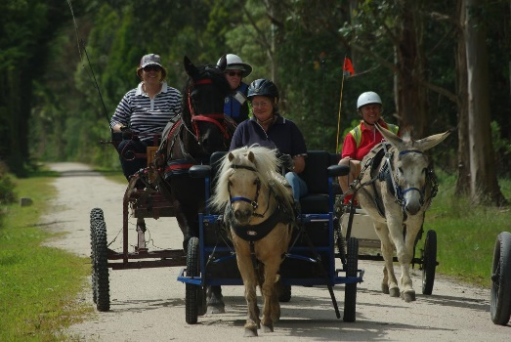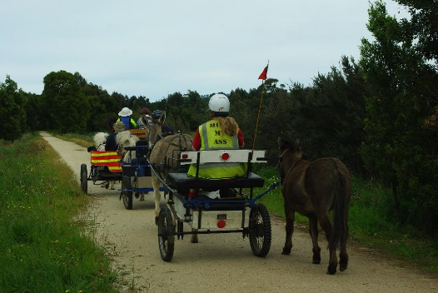

Note: Medical armbands must be worn by both driver and groom.
Hi Vis vests must be worn by 1 person in the carriage.
Road rules must be followed.
Disclaimer forms must be signed.
ACDS Vic Branch Heat Policy will be adhered to.

Entry for the 4 days $100 self-funded or made up with sponsors if you wish.
Or Entry per day $40 self-funded or made with sponsors.

Limit of 20 Entries due to limited yards and camping. More can come if not camping

Donations in the form of goods would be greatly appreciated for a raffle.

We encourage you to collect more sponsors for a bigger donation! The more sponsors the better!

Entrants must be a member of the ACDS for insurance reasons or pay the $30 insurance for the event.

Entries close: 15th January 2022, All entries to Leanne Prosser

For more information; contact:
Leanne Prosser. ranleighponystud@yahoo.com.au 51924662 or 0427924662
or
Jane Reid. magic04@live.com.au 0417164282

