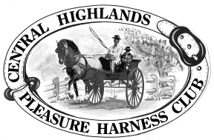

Central Highlands Pleasure Harness Club
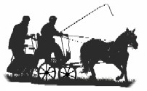
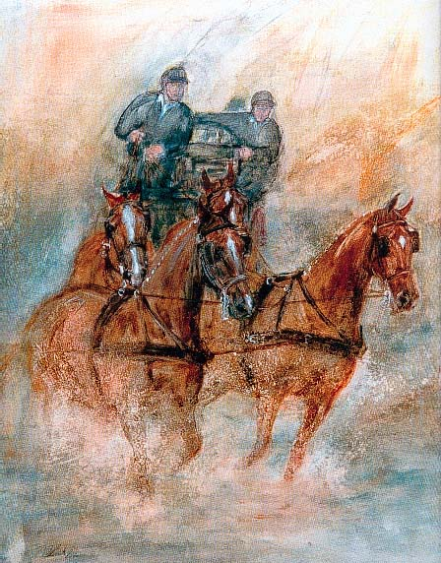
Indoor/Outdoor Carriage
Driving Competition
Precision, Speed, Excitement.

Saturday 3rd and Sunday 4th July
Huntly Equine Recreation Reserve 455 Millwood Rd Huntly

EVENT OFFICIALS
Event Supervisor - Laraine Blume
Event Secretary - Hilary Billett
Precision and Paces Judges - Gwenifer Hack, Esther Goodwin
Scorer - Central Highlands
Cones & Obstacle Judge - Phil Marshall

Judges decisions are final
PROGRAMME
EVENT 1
Indoor Carriage Driving - 3 phases

A- Precision & Paces
Arena 50m x 20m
Indoor HDT dressage test No. 10 all classes

B- Cones
Driven at 220 metres per minute, approximately fast trot.
No stopwatches allowed.

C- Obstacles
EVENT 2
Speed Cones - One round-fastest, clear round to win.
SCHEDULE
Event 1 Indoor Carriage Driving

- Very Small Equines (under 91cm)
- Single Pony 91cm ne 124cm
- Single Pony 124cm ne149cm
- Single Horse Over 149cms
- Multiples, any Height

Event 2 Speed Cones

9. Single any height.
10. Multiple any height

APPROXIMATE TIMETABLE
9am Precision and Paces.
Cones to follow
1pm 1st round Obstacles
2pm 2nd round obstacles re-lettered, Drivers have 10 minutes to learn new course.

Tea, Coffee available. Outdoor arena. Overnight camping allowed, showers, toilets, no power available.

QUALIFICATIONS FOR FINAL

Competitors must compete and successfully complete two qualifying indoor competitions in the current season to be eligible to compete at the 2021 Championships. In the case of multiples, each pony/horse must have successfully completed two qualifying indoor competitions in the current season to be eligible (not necessarily in the combination to be used at the final)

Enquiries:
Event secretary Hilary Billett 0419 104 583
Entry fee $40 per day
(inc. speed cones)
Camping Fee $5 per head for 2 days
Yard $5 for 2 days
ENTRIES CLOSE
Friday 25th June
ENTRIES TO
Email entry form to hbillett@bendigotafe.edu.au
or post to Hilary Billett, PO Box 237, EPSOM, VIC 3551 – please email to advise they have been posted
Direct Deposit to Bendigo Bank
Name: Central Highlands Pleasure Harness Club
BSB: 633000 Account No 136 533 098
or
Cheques/Money Orders made payable to the Central Highlands Pleasure Harness Club
Entries will not be accepted without payment.

- First Season Driver

CONDITIONS OF ENTRY
- The Event will be judged under the current Australian Indoor Horse Driving Rules and any additional conditions included in this schedule.
- Drivers must be full members of the ACDS and horses must be ACDS registered.
- All competitors compete at their own risk.
- Junior drivers age 6 -10 must be accompanied in the vehicle by an ACDS adult member (an experienced driving person) seated next to the driver at all times and holding a second pair of reins attached to the bit. Junior Drivers 11-15 must be accompanied in the vehicle by an ACDS adult member (an experienced driving person).
- Livestock control: Entrants /Owners of livestock are advised that horses must be adequately and securely restrained and controlled at all times.
- Dress code: Marathon gear, gloves and whip. Protective headgear is compulsory in accordance with ACDS rules.
- Medical armbands to be worn by Drivers and Grooms.

