SOUTHERN CROSS HARNESS CLUB
AND
EASTERN VIC PLEASURE HARNESS CLUB
CHARITY DRIVE
25th- 27th January 2020
WE ARE HOSTING A 3 DAY PLEASURE DRIVE/RIDE ALONG THE Great Southern RAIL TRAIL. ALL PROCEEDS WILL BE DONATED TO THE PROSTATE CANCER FOUNDATION OF AUSTRALIA (PCFA)
“The PCFA is a broad-based community organization and the peak national body for prostate cancer in Australia. They are dedicated to reducing the impact of prostate cancer on Australian men, their partners and families, recognising the diversity of the Australian Community.”
On Thursday 23rd and Friday 24th Camping is available at the Leongatha Adult riding club in Tilson Crt, for those travelling a distance. There are horse yards, toilets and showers available. Each day you will get ferried back to get your car and float to move to the next campsite. Support vehicle will carry you buckets, hay etc.
Day 1: Leongatha to Buffalo 28km approx.
All days there will be a “muster” at 9am to brief before we leave. The drive will commence at Leongatha 10-10.30 (earlier if a hot day) for briefing and morning tea. WIN Tv may be there to cover the event and we will be officially sent off by Harriet Shing the Eastern Victoria Region MP. BYO or buy Lunch at Meeniyan (approx. 18km) and finish at Buffalo Recreation Reserve Hall (approx. 15km). Toilets, showers and kitchen facilities available. Longline or portable yards for horses. Camp the night or sleep in the Hall. Dinner at Meeniyan Pub with a shuttle bus service.
Day 2: Buffalo to Bennison 27km approx.
9am Muster. Leave Buffalo 10-10.30 (earlier if hot day). BYO or pre order Lunch Linton Rd, Foster (approx. 18km). Camp the night at Bennison Pony club (approx. 11km). Showers, toilets, horse wash water and yards. Dinner delivered Pizza etc at own cost.
Day 3: Bennison to Port Welshpool 21km approx.
9am Muster. Leave 10-10.30 (earlier if hot day). BYO or pre order Lunch, Barry Rd, Agnes (approx. 15 km). Finish at Port Welshpool (approx. 12 km). We are staying a a private property on the foreshore. (bring your bathers)Pub for dinner available. Camp another night if required. Long line or portable yards. The raffle will be drawn at Port Welshpool.
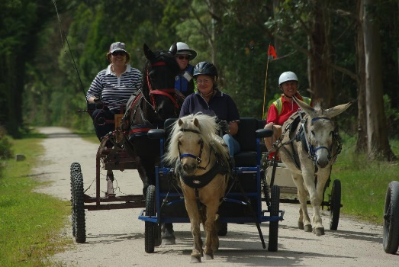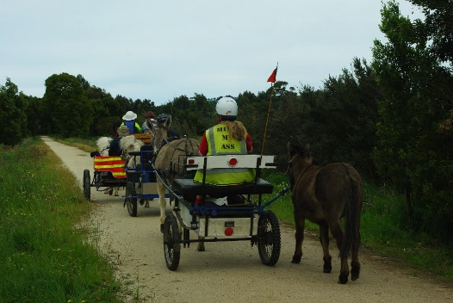

Note: Medical armbands must be worn by both driver and groom.
Hi Vi vests must be worn by 1 person in the carriage.
Road rules must be followed.
Disclaimer forms must be signed.
ADS heat policy will be adhered to.

Entry for 3 days $100 self funded or made up with sponsors if you wish.
Entry per day $40 self funded or made with sponsors.
Limit of 20 Entries due to limited yards and camping. More can come if not camping
Donations in the form of goods would be greatly appreciated for a raffle.
We encourage you to collect more sponsors for a bigger donation! The more sponsors the better!
Entrants must be a member of the ACDS for insurance reasons or pay the $30 insurance for the event.
Entries close: 15th January 2020
Contact; Leanne Prosser. ranleighponystud@yahoo.com.au
51924662 or 0427924662
Jane Reid . magic04@live.com.au
0417164282
