Central Highlands Pleasure Harness Club
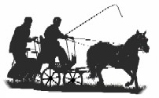
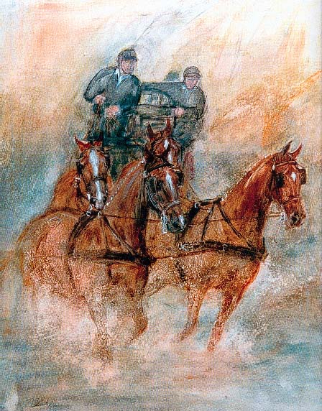
Indoor Carriage
Driving Competition
Precision, Speed, Excitement.

Saturday 6th and Sunday 7th July
Huntly Equine Recreation Reserve
455 Millwood Rd HUNTLY

EVENT OFFICIALS
Event Supervisor - Laraine Blume
Event Secretary - Hilary Billett
Precision and Paces Judges - Margie Morgan, Prue McKechnie
Scorer - Hilary Billett
Cones & Obstacle Judge - Karen Rogers

Judges decisions are final
PROGRAMME
EVENT 1
Indoor Carriage Driving - 3 phases

A- Precision & Paces
Arena 50m x 20m
Indoor driving test No. 2019-1 all classes

B- Cones
Driven at 220 metres per minute, approximately fast trot.
No stopwatches allowed.

C- Obstacles
EVENT 2
Speed Cones - One round-fastest, clear round to win.
SCHEDULE
Event 1 Indoor Carriage Driving

1. Single Pony 91cms & Under 121cms (9hh & Under 11.3 3/4hh)
2. Single Pony 121cms n.e.149cms (11.3 3/4hh n/e. 14.2 5/8hh)
3. Single Horse Over 149cms (Over 14.2 5/8hh)
4. Multiple any Height
5. First Season Competitor
6. VSE’s (under 91cms)

NOTE* VSE’s will be run first

Event 2 Speed Cones

9. Single any height.
10. Multiple any height

APPROXIMATE TIMETABLE
9am Precision and Paces.
Cones to follow
1pm 1st round Obstacles
2pm 2nd round obstacles re-lettered, Drivers have 10 minutes to learn new course.

Tea, Coffee and full canteen available for breakfast and lunch each day. Overnight camping available free of charge, showers, toilets, kitchen, clubroom.

QUALIFICATIONS FOR FINAL

Competitors must compete and successfully complete two qualifying indoor competitions in the current season to be eligible to compete at the 2019 Championships. In the case of multiples, each pony/horse must have successfully completed two qualifying indoor competitions in the current season to be eligible (not necessarily in the combination to be used at the final)

Enquiries:
Hilary Billett 0419104583 hbillett@bendigotafe.edu.au
Entry fee $40 per day
(inc. speed cones)
Camping Fee $ no charge
Yards $5 per yard
Indoor Stables $NA
ENTRIES CLOSE
Monday 1st July
ENTRIES TO
H Billett
PO Box 237 EPSOM Vic 3551 or

Cheques/Money Orders made payable to Central Highlands Pleasure Harness Club
or if you wish to direct deposit entry fee:
Direct Debit to:
Bendigo Bank
Name: CHPHC
BSB: 633 000 Accnt No 136533098
or email to hbillett@bendigotafe.edu.au

Entries will not be accepted without payment.

CONDITIONS OF ENTRY
- The Event will be judged under the current Australian Indoor Horse Driving Rules and any additional conditions included in this schedule.
- Drivers must be full members of the ACDS and horses must be ACDS registered.
- All competitors compete at their own risk.
- Junior drivers age 10 must be accompanied in the vehicle by an ACDS adult member (an experienced driving person) seated next to the driver at all times and holding a second pair of reins attached to the bit. Junior Drivers 11-15 must be accompanied in the vehicle by an ACDS adult member (an experienced driving person).
- Livestock control: Entrants /Owners of livestock are advised that horses must be adequately and securely restrained and controlled at all times.
- Dress code: Marathon gear, gloves and whip. Protective headgear is compulsory in accordance with ACDS rules.
- Medical armbands to be worn by Drivers and Grooms.
- Parents are responsible for the supervision of children at all times at this venue

