Hill Tops Carriage Driving Club
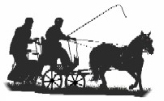
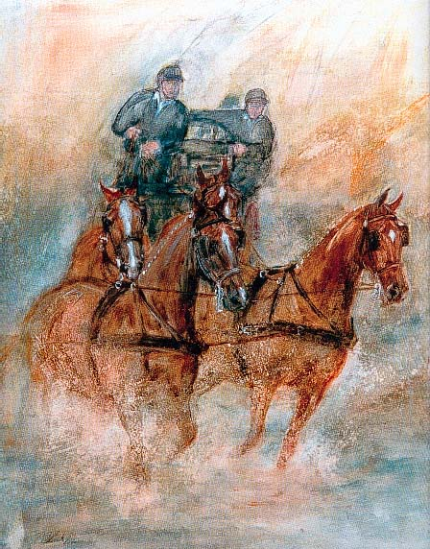
NSW
Indoor/Outdoor Carriage
Driving Competition
Precision/Speed/Excitement.

1st and 2nd June 2019
Tumut Show Ground
Cnr East Street and Grant Street Tumut

EVENT OFFICIALS
Event Supervisor – Debbie Dunn
Event Secretary – Tess Smith
Precision and Paces Judges - Lynne Dominish / Elissa Schuhkraft
Scorer - Kim Dunn
Cones & Obstacle Judges - Ray Dominish / Steve Kearns

Judges decisions are final
PROGRAMME
EVENT 1
Indoor Carriage Driving - 3 phases

A- Precision & Paces
Arena 50m x 20m
Indoor driving test No. 2017-1 all classes

B- Cones
Driven at 220 metres per minute, approximately fast trot.
No stopwatches allowed.

C- Obstacles
EVENT 2
Speed Cones - One round-fastest, clear round to win.
SCHEDULE
Event 1 Indoor/Outdoor Carriage Driving

1. Single Pony 91cms & Under 121cms (9hh & Under 11.3 3/4hh)
2. Single Pony 121cms n.e.149cms (11.3 3/4hh n/e. 14.2 5/8hh)
3. Single Horse Over 149cms (Over 14.2 5/8hh)
4. Multiple any Height
5. First Season Competitor
6. VSE’s (under 91cms)
7. Junior

Event 2 Speed Cones (optional)

9. Single any height.
10. Multiple any height

APPROXIMATE TIMETABLE
10am Precision and Paces.
Cones to follow
1pm 1st round Obstacles
Followed by 2nd round obstacles re-lettered
(Optional at qualifier)
– Drivers have 10 minutes to learn new course.

Tea and Coffee available.

Overnight camping, showers, toilets, horse yards.
(Dinner Saturday night)

QUALIFICATIONS FOR FINAL

Competitors must compete and successfully complete two qualifying indoor competitions in the current season to be eligible to compete at the 2019 Finals. In the case of multiples, each pony/horse must have successfully completed two qualifying indoor competitions in that combination in the current season to be eligible.

Enquiries: Debbie Dunn - 0407472361
Entry fee - $60 (2 days / inc. speed cones, yards, camping)

$40 (day entry / inc. speed cones)

Dinner - $20 (Saturday evening meal Italian Extravaganza)

ENTRIES CLOSE
Monday 27th May 2019
ENTRIES TO
Tess Smith – 6 Wood St, Grenfell NSW 2810

Cheques/Money Orders made payable to
Hill Tops Carriage Driving Club
Or if you wish to Direct Deposit entry fee:
Direct Debit to: Hill Tops Carriage Driving Club
Name of bank: Westpac
BSB: 032 744 Account No: 197017
Email to: theresesmith12@bigpond.com
Entries will not be accepted without payment

CONDITIONS OF ENTRY
- The Event will be judged under the current Australian Indoor Horse Driving Rules and any additional conditions included in this schedule.
- Drivers must be full members of the ACDS and horses must be ACDS registered.
- All competitors compete at their own risk.
- Junior drivers age 10 must be accompanied in the vehicle by an ACDS adult member (an experienced driving person) seated next to the driver at all times and holding a second pair of reins attached to the bit. Junior Drivers 11-15 must be accompanied in the vehicle by an ACDS adult member (an experienced driving person).
- Livestock control: Entrants /Owners of livestock are advised that horses must be adequately and securely restrained and controlled at all times.
- Dress code: Marathon gear, gloves and whip. Protective headgear is compulsory in accordance with ACDS rules.
- Parents are responsible for the supervision of children at all times at this venue.

