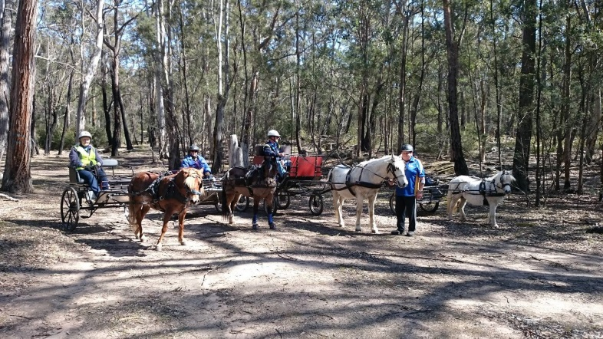

Prostate Cancer Charity drive
26th-28th January ,2018

Hosted by
Eastern Vic Pleasure Harness Club
and
Southern Cross Harness Club.

3 day drive.Starting at Toongabbie and finishing at Maffra along the Gippsland plains Rail trail.
Sponsorship welcome.
Contact: Leanne Prosser
ranleighponystud@yahoo.com.au
Jane Reid
magic04@live.com.au

