EVENT OFFICIALS

Event Supervisor – **Mandy Lawrence**

Event Secretary – **Tracey Tuohy**

Precision and Paces Judges

Sat & Sun - **Les Morrison**

**Sat - Katrina Wattchow**

**Sun – Cheryl Dowling**

Scorer – Bernadette Lewis

Cones & Obstacle Judges –

Kim Damsma and Deb Hoffrichter

**Judges decisions are final**

**PROGRAMME**

**EVENT 1**

Indoor Carriage Driving - 3 phases

**A- Precision & Paces.** Arena 50m x 20m

**Indoor driving test No. 2017-1 all classes**

**B –Cones** Driven at 220 metres per minute, approximately fast trot. No stopwatches allowed.

**C- Obstacles**

**EVENT 2**

Speed Cones – One round-fastest, clear round to win.

**SCHEDULE**

**Class 1**

**1.A.** Single Pony 91cms & Under 121cms (9hh & Under 11.3 3/4hh)

**1.B** Single Pony 121cms n.e.149cms (11.3 3/4hh n/e. 14.2 5/8hh )

**1.C** Single Horse Over 149cms (Over 14.2 5/8hh)

**1.D** Multiple any Height

**1.E** First Season Competitor

**1.F** VSE’s (under 91cms)

**Class 2**

Speed Cones

**2.A.** Single any height.

**2.B.** Multiples any height

Note: all classes minimum 125cm wheel width and joggers/pneumatic tyres permitted in all classes

**APPROXIMATE TIMETABLE**

*Precision and Paces starting time to be advised.

*Drivers to complete Cones directly after precision and paces

*NO OBSTACLES TO BE WALKED BY COMPETITIORS UNTIL OBSTACLE JUDGE ADVISES ON THE DAY

**CONDITIONS OF ENTRY**

The Event will be judged under the current Victorian Indoor Horse Driving Rules dated 1 March 2018 and any additional conditions included in this schedule.

1. Drivers must be full members of the ACDS and horses must be ACDS registered.
2. All competitors compete at their own risk.
3. Junior drivers age 10 must be accompanied in the vehicle by an ACDS adult member (an experienced driving person) seated next to the driver at all times and holding a second pair of reins attached to the bit. Junior Drivers 11-15 must be accompanied in the vehicle by a ACDS adult member (an experienced driving person).
4. Livestock control: Entrants /Owners of livestock are advised that horses must be adequately and securely restrained and controlled at all times.
5. Dress code: Marathon gear, gloves and whip. Protective headgear is compulsory in accordance with ACDS rules.
6. **Medical armbands to be worn by Drivers and Grooms.**
7. **Parents are responsible for the supervision of children at all times at this venue.**
8. **NO DOGS allowed at the reserve, anyone bringing dogs will be asked to leave**

**QUALIFICATIONS FOR FINAL**

Competitors must compete and successfully complete two qualifying indoor competitions in the current season to be eligible to compete at the 2018 Championships. In the case of multiples, each pony/horse must have successfully completed two qualifying indoor competitions in the current season to be eligible (not necessarily in the combination to be used at the final)

**Mornington Peninsula Pleasure**

**Harness Club**



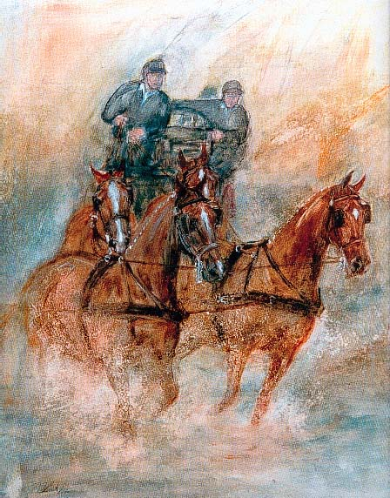

**Indoor/outdoor Carriage**

**Driving Competition**

*Precision, Speed, Excitement.*

**Sat 30th June and Sun 1st July 2018**

Emu Plains Reserve

Coolart Road, Balnarring

Enquiries: **Tracey Tuohy**

**Phone 0422 118 459**

**Email traceytuohy@bigpond.com**

Direct Debit to: **Bendigo Bank**

BSB**: 633 000** Account No**: 1509 68576**

Entry fee $40 one day/$70 Two days

(inc speed cones)

Entries will not be accepted without payment. Please email your payment receipt with your entry

Entries Close 25th June

##### No late entries will be accepted.

##### Tea, Coffee and lunch will be available

**Camping at Emu Plains by prior arrangement only**